**Midpoint circle algorithm**

In [computer graphics](https://en.wikipedia.org/wiki/Computer_graphics), the midpoint circle algorithm is an algorithm used to determine the points needed for [rasterizing](https://en.wikipedia.org/wiki/Rasterizing) a [circle](https://en.wikipedia.org/wiki/Circle). . [Bresenham](https://en.wikipedia.org/wiki/Bresenham" \o "Bresenham)'s circle algorithm is derived from the midpoint circle algorithm.[

It is based on the following function for testing the spatial relationship between the arbitrary point (x, y) and a circle of radius r centered at the origin:

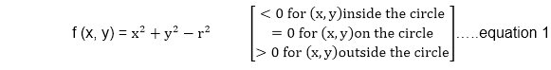  
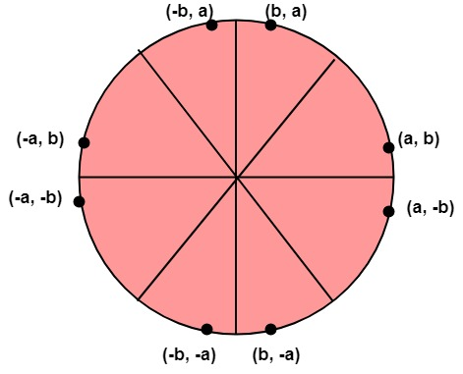

Now, consider the coordinates of the point halfway between pixel T and pixel S

This is called midpoint (xi+1,yi-MidPoint Circle Algorithm) and we use it to define a decision parameter:

            Pi=f (xi+1,yi-MidPoint Circle Algorithm) = (xi+1)2+(yi-MidPoint Circle Algorithm)2-r2 ...............equation 2

If Pi is -ve ⟹midpoint is inside the circle and we choose pixel T

If Pi is+ve ⟹midpoint is outside the circle (or on the circle)and we choose pixel S.

The decision parameter for the next step is:

Pi+1=(xi+1+1)2+(yi+1-MidPoint Circle Algorithm)2- r2............equation 3

Since xi+1=xi+1, we have

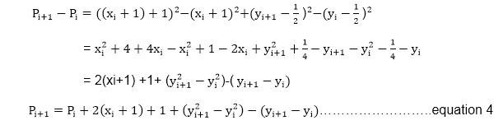

If pixel T is choosen ⟹Pi<0

We have yi+1=yi

If pixel S is choosen ⟹Pi≥0

We have yi+1=yi-1

MidPoint Circle Algorithm

We can continue to simplify this in n terms of (xi,yi) and get

MidPoint Circle Algorithm

Now, initial value of Pi (0,r)from equation 2

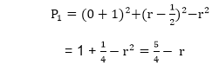

We can put MidPoint Circle Algorithm≅1  
∴r is an integer  
So, P1=1-r

Algorithm:

**Step1:** Put x =0, y =r in equation 2  
            We have p=1-r

**Step2:** Repeat steps while x ≤ y  
            Plot (x, y)  
            If (p<0)  
Then set p = p + 2x + 3  
Else  
            p = p + 2(x-y)+5  
            y =y - 1 (end if)  
            x =x+1 (end loop)

**Step3:** End

**Advantages and disadvantages of the midpoint circle algorithm**

**Advantages;**

It helps in scan-conversion algorithms very efficiently, by drawing the curves on display of raster.

The Non-Parametric Equations are easily transformed by this method using a function (f(X, Y)=0), in order to describe the curve, to draw a curve and convert it to algorithms.

**Disadvantages;**

It consumes a lot of time.

The distance between the pixels is not equal hence the circle may not be smooth.